|  |
| --- |
| **Write: Record the given question in the space below.** |
| **Think: What is your response?**   |

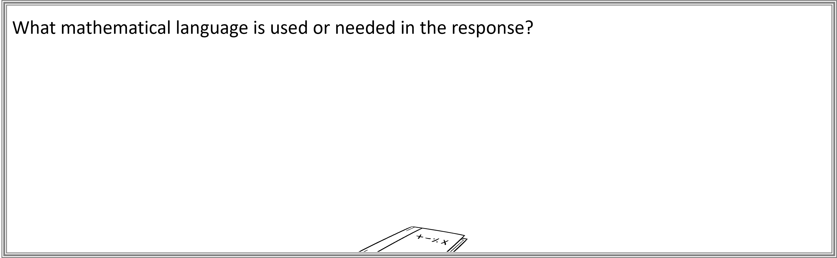

**Revise: What is your final response?**

|  |
| --- |
| **Write: Record the given question in the space below.** |
| **Think: What is your response?**   |



**Revise: What is your final response?**